   | Policy No: S56 | Revision No: | 7
 | Policy No: S56 | Date Issued: | November 2016
 | Policy No: S56 | Committee: | Full Governing Body
 | Attendance Policy | Author: | Partnership of Dronfield Schools (PoDS)
 | Attendance Policy | Date Adopted: | November 2025
 | Attendance Policy | Minute No: | 3.12.25, min no 17.5
 | Attendance Policy | Review Date: | November 2026



FEDERATION OF PENNY ACRES AND WIGLEY PRIMARY SCHOOL

ATTENDANCE
POLICY

Introduction

This policy has been written to adhere to the relevant Children Acts, Education Acts, Regulations and Guidance from the Department for Education in addition to guidance from the Local Authority. Parents/carers have the legal responsibility for ensuring their child’s regular attendance and failure to do so is a criminal offence under Section 444 of the Education Act 1996.

Ethos

In the Federation of Penny Acres and Wigley Primary Schools, we want our pupils to:

- Be resilient, reflective and to take responsibility for what they do.
- Be motivated and enjoy learning
- Develop a range of skills to equip them for a successful adult life, such as independence and ambition
- Be confident, happy and feel safe
- Be friendly, respectful, caring and polite
- Develop and demonstrate skills and attitudes that will allow them to participate fully in and contribute positively to life in modern Britain.

In schools that:

- Foster individual talents and abilities in every child
- Have the highest expectations for itself, its staff and students
- Celebrate success and achievement in all its forms
- Value the role parents and carers play
- Are continually striving to improve.
- Actively promote the fundamental British values of democracy, the rule of law, individual liberty and mutual respect and tolerance of those with different faiths and beliefs.

Aims and Objectives

This attendance policy ensures that all staff, governors and parents in our school are fully aware of and clear about the actions necessary to promote good attendance.

Through this policy we aim to:

We are committed to meeting our obligations with regards to school attendance by:

- Promoting good attendance and reducing absence, including persistent absence
- Ensuring every pupil has access to full-time education to which they are entitled
- Acting early to address patterns of absence
- Support parents to perform their legal duty to ensure their children of compulsory school age attend regularly, and will promote and support punctuality in attending lessons.
- Establish a culture and climate, which will:
- Enable all students to feel we are a safe and a happy place to learn.
- Endeavour for 100% attendance and punctuality by all students.
- Actively promote excellent attendance and discourage unjustified absence.
- Recognise and celebrate excellent attendance and punctuality
- Prepare students for the demands and disciplines of adult working life.

The School Day

Registration periods

The ‘AM’ mark is recorded when students arrive in the morning. This period starts at 8:40am (Wigley) and 8:50am (Penny Acres) and registers are therefore open until 9:15am. The ‘PM’ mark is recorded at the start of period 4 (13:30pm) with registers being open 13:30pm – 13:45pm. If a student arrives late, after the close of the register, without good reason they will receive a ‘U’ mark. This will be classed as an unauthorised absence from school. Students who arrive before the close of the register will receive an ‘L’

Types of Absence

Authorised absence

- An absence is classified as authorised when a child registered at our school has been away from school for a legitimate unavoidable reason and the school has received notification from a parent or carer. For example, if a child has been unwell and the parent telephones the school to explain the absence.

Only the Headteacher can decide on whether an absence is authorised or not. Sometimes, even if absence is supported by parent, an absence may be unauthorised. The headteacher will base this decision using the NAHT Guiding Principles as stated in Appendix A.

Unauthorised absence

- An absence is classified as unauthorised when a child (including under 5s) is away from school without the permission of the school even if the absence is supported by the parent.

Responsibilities

All members of Federation staff have a responsibility for identifying trends in attendance and punctuality. The following includes a more specific list of the kinds of responsibilities which individuals might have.

The Senior Attendance Champion (key person) within school who is responsible for the attendance of pupils is Mr David Ratcliffe (Executive Headteacher).

Parents/carers:

- Ensure their child attends daily, punctually, dressed in full uniform and equipped to learn – “smart students, ready to learn and “on time, all the time”.
- If late in the morning, sign in at the school office.
- If need to leave early sign out at the school office.
- Tell a member of staff if there are problems attending school for any reason, e.g. being bullied, feeling unhappy, problems at home.
- Telephone and speak to the school office on the first day of absence ideally before 8.30am. If a student continues to be absent school will contact daily until they return to school.
- Where possible make any medical or dental appointments outside of school hours or not in term time.
- Bring a copy of any medical appointment cards/texts to school if requiring time off from school.
- Do not book any holidays or take children out of school during term time.
- Notify school as soon as problems arise with your child’s attendance.
- Encourage children to report any issues that are concerning them, including bullying, immediately to school staff.

Students:

- Arrive in school by times listed above.
- Attend every timetabled session on time.
- Be “On time, all the time”.
- If late remind your parents/carers to sign you in.

Headteacher/Assistant Headteacher

- Share attendance weekly with pupils through assemblies
- Strategically lead and develop the school roles outlined previously.
- Work on strategic action plans and school policy that bring about improvements in student attendance
- Lead on School Attendance Panels and ensure targets and future intervention is administered.
- Monitor and evaluate the systems in school designed to support students in their academic progress and their health and well-being.
- Monitor and evaluate school systems and interventions designed to promote exceptional attendance and behaviour.
- Implementation of the policy at the school
- Monitoring school level absence data and report it to governors
- Support staff with monitoring the attendance of individual pupils
- Monitoring the impact of any implemented attendance strategies
- Issuing fixed-penalty notices, where necessary.

School Business Officer

- Keep accurate records of responses from parents/carers when their child is absent.
- Amend the electronic register accordingly.
- Make contact with parent/carer if no contact has been received in the morning of the first day of a child’s absence (by text or telephone call).
- Monitor students for truancy and lateness.
- Report concerns about behaviour, attendance or punctuality promptly to other school colleagues.
- Monitor students with poor attendance.
- Issue attendance awareness and warning letters to parents/carers where appropriate.
- Contact Social Services immediately on the first day of absence of a student with a Child Protection Plan, Child in Need or a Child in Care.

Class Teacher

- Be a good role model for students by arriving on time and being ready for the school day
- Be responsible for recording attendance on a daily basis, promptly and accurately, using the correct codes and submitting this information to the school office.
- Give attendance and punctuality the highest profile, sharing attendance figures with students.
- Praise students for arriving on time.
- Share any concerns about the attendance, punctuality or welfare of students promptly with SLT and parents/carers.

School Staff

- Be a good role model for students by arriving on time and being ready for the school day

The Governing Board:

- Promoting the importance of school attendance across the school’s policies and ethos.
- Making sure school leaders fulfil the expectations and statutory duties.
- Review and challenge attendance data.
- Monitoring attendance figures for the whole school.
- Making sure staff receive adequate training on attendance.
- Holding the headteacher to account for the implementation of this policy.

Procedures

Registration

Each class teacher has the responsibility for marking the attendance register at the beginning of the morning and afternoon session.

All attendance records are documented using RM Integris. Attendance registers are legal documents and these must be kept secure and preserved in line with the relevant retention schedule

Lateness and punctuality

A pupil who arrives late:

- Before the register has closed will be marked as late, using the appropriate code.
- After the register has closed will be marked as absent, using the appropriate code.
- Parents will be required to inform school of the reason for the lateness of arrival.

Any pupil who comes into school after 8:50am will be marked as late. Records are kept of those pupils who are late; this is documented on the electronic register for each pupil (Attendance code L).

Any child who arrives for school later than 9:15am will be marked as late after close of register (Attendance code U). This is an unauthorised absence for the whole session and will affect your child’s overall attendance percentage and can be used to calculate absence thresholds for legal decision making.

Children who have attended a dentist or doctor’s appointment and subsequently come to school late will have the absence recorded as a medical absence (Attendance code M).

First Day Contact

Where a child is absent from school and we have not received any contact from the parent, then we initiate a first day contact process. Office staff check all of the registers each morning to identify those pupils who are absent without explanation and, as a safeguarding requirement, make contact with the parents of these children by telephone.

Illness (Unplanned Absence)

The student’s parent/carer must notify school on the first day of an unplanned absence by 9:15am or as soon as practically possible.

We will mark absence due to illness as authorised unless the school has a genuine concern about the authenticity of the illness.

If the school is not satisfied about the authenticity of the illness, the absence will be recorded as unauthorised and parents/carers will be notified of this in advance.

Parents are required to inform school each day of absence, with an update an expected return to school date.

Planned absence (Medical)

Attending a medical or dental appointment will be counted as authorised as long as the pupil’s parent/carer notifies the school in advance of the appointment.

However, we encourage parents/carers to make medical and dental appointments out of school hours where possible. Where this is not possible, the pupil should be out of school for the minimum amount of time necessary.

The pupil’s parent/carer must also apply for other types of term-time absence as far in advance as possible of the requested absence.

Medical Evidence

If the authenticity of the illness is in doubt, or the school considers a student’s absence to be high or following an unusual pattern, then parents/carers may be asked to provide additional medical evidence to help explain any illness absence.

Additional medical evidence may include a doctor’s appointment card/text or a photocopy of a pharmacy prescription. The purpose of parents/carers providing additional medical evidence is to help school make fair and objective decisions over which absences are genuine and which are non-genuine illness.

School will not pay any charges incurred by the writing of a doctor’s note. If the school has previously written to parents/carers requesting additional medical evidence and none is provided, then the absence will be classified as unauthorised.

We will not ask for medical evidence unnecessarily.

Where medical evidence is requested, but not provided, an ‘O’ code will be used to indicate unauthorised.

Applications for Leave of Absence in Term Time

In September 2013 the government introduced new regulations making it clear that Headteachers must not give approval for any leave of absence during term time, including holidays, unless there are exceptional circumstances.

Any requests for term time leave should be made on a PODS Request of Absence from the school office and handed in 4 school weeks before the first date of the requested absence whenever possible. You must have received written authorisation before your child can be absent from school.
See Appendix C Pods Absence form and Attendance flyer to be included with the form.

Parent/carers may be issued with a penalty notice fine or prosecution should leave of 5 days or more be taken which is not authorised by the Headteacher, or where repeated incidents of leave in term time for less than 5 days occur or where the unauthorised absence contributes to wider poor attendance that meets the legal threshold. (Attendance code G).

Absence deemed for the reason of unauthorised leave in term time will be marked in the register with the Attendance code G.
You may be issued with a Penalty Notice should leave be taken which is not authorised. If unpaid this could lead to prosecution under section 444(1) of The Education Act 1996.
See Appendix D DCC Term Time Absence Flowchart

Granting Leave of Absence

All schools can grant a leave of absence when a pupil needs to be absent from school with permission. All schools are expected to restrict leaves of absence to the specific circumstances set out in regulation 11 of the School Attendance (Pupil Registration) (England) Regulations 2024 and schools maintained by a local authority and special schools not maintained by a local authority must do so.

These circumstances are:

  - Taking part in a regulated performance or employment abroad: in line with a licence issued by a local authority or Justice of the Peace or a body of persons approval (BOPA).
  - Attending an interview: for entry into another educational institution or for future employment where requested in advance by a parent the pupil normally lives with.
  - Study leave: for public examinations, as agreed in advance with a parent the pupil normally lives with. Please note this does not include any internal examinations such as mocks as study leave should not be granted in such cases.
  - A temporary, time-limited part-time timetable: where the pupil is of compulsory school age, both the parent who the pupil normally lives with and school agree the pupil should temporarily be educated on a part-time basis for exceptional reasons and have agreed the times and dates when the pupil will be expected to attend school as part of that timetable.
  - Exceptional circumstances: All schools can grant a leave of absence for other exceptional circumstances at their discretion. In the case of schools maintained by local authorities and special schools not maintained by local authorities, it must be requested in advance by a parent who the pupil normally lives with. Schools are then expected to consider each application individually taking into account the specific facts and circumstances and relevant background context behind the request. If a leave of absence is granted, it is for the school to determine the length of the time the pupil can be away from school.
  - See Appendix A NAHT Guiding Principles
  - See Appendix E Letters to Parents Term Time Leave

National Framework for Penalty Notices (Fixed Penalty Notices)

The new national threshold for consideration of legal action is 10 sessions of unauthorised absence in a rolling period of 10 school weeks. A school week means any week in which there is at least one school session. This can be met with any combination of unauthorised absence, including lates after close of register (Attendance code U) and unauthorised leave in term time (Attendance code G).

If your child’s absence falls into this category the school will decide if further offers of support is likely to improve the situation or if a request for legal action should be submitted to the Local Authority.

Addressing Attendance Concerns

Schools are open for 380 sessions or 190 school days each year.

The Federation of Penny Acres and Wigley expects attendance of at least 96%. This equates to not more than 15 lost sessions over a school year.

It is important for children to establish good attendance habits early on in their school career. It is the responsibility of the Headteacher and the governors to support good attendance and to identify and address attendance concerns promptly. We rely upon parents to ensure their child attends school regularly and punctually and therefore where there are concerns regarding attendance parents are always informed of our concerns.

From August 19 2024 the Working Together to Improve School Attendance suggests that absence is reported in terms of ‘sessions absent’ to make the data easier to access.

See Appendix F DCC Attendance flowchart

The Process for Supporting Attendance.

The school follows the Derbyshire systematic process of support for students whose attendance falls below expected levels (96%). We will consider intervention with parents/carers if a student’s attendance is less than 96% terms 1-6.

See Appendix E DCC Letters re: Attendance

Fixed Penalty Notices will be issued in accordance with the National Framework for Penalty Notices (Appendix G)

See Appendix J Request to LA for formal commencement of statutory parental responsibility measures/legal action in relation to school attendance.
We will take into account the time of the academic year and student’s circumstances before this academic year

Contact with Social Services – If a student with a Child Protection Plan is absent from school for any reason, the named social worker should be contacted immediately.

Support Available for Students and Families

A range of support is available in and outside of school to support students and their families to achieve excellent attendance.

They include:

- CAMHS (Child and Adolescent Mental Health Service) – referral to CAMHS has to be through school health or the family’s own GP
- Schools will also share the NHS resource ‘Is my Child Too Ill for School? To help support families. This can be found at https://www.nhs.uk/live-well/is-my-child-too-ill-for-school/

Appendix A
NAHT Guiding Principles
Term times are for education. This is the priority. Children and families have 175 days off school to spend time together, including weekends and school holidays. Head teachers will rightly prioritise attendance. The default school policy should be that absences will not be granted during term time apart from in ‘exceptional circumstances’
The decision to authorise a pupil’s absence is wholly at the head teacher’s discretion based on their assessment and merits of each request
If an event can be reasonably scheduled outside of term time, then it would not be normal to authorise absence for such an event – holidays are, therefore, not considered ‘exceptional circumstances’
Absences to visit seriously-ill relatives or for bereavement of a close family member are usually considered to amount to ‘exceptional circumstances’, but for the funeral service and travelling time only, not for extended leave
Absences for important religious observances are often considered, but only for the ceremony and travelling time, not for extended leave. This is intended for one-off situations rather than regular or recurring events
Schools may wish to take the needs of the families of service personnel into account if they are returning from long operational tours that prevent contact during scheduled holiday time
Schools must make reasonable adjustments for pupils with special educational needs or disabilities
Families may need time together to recover from a trauma or crisis
It is acceptable to take a pupil’s record of attendance into account when making absence-related decisions
It is important to note that head teachers can determine the length of the authorised absence as well as whether an absence is authorised.
Appendix B – Attendance and Absence Codes
Attending the school:

- Code / \: Present at the school / = morning session \ = afternoon session
- Code L: Late arrival before the register is closed

Attending a place other than the school

- Code K: Attending education provision arranged by the local authority
- Code V: Attending an educational visit or trip
- Code P: Participating in a sporting activity
- Code W: Attending work experience
- Code B: Attending any other approved educational activity
- Code D: Dual registered at another school

Absent - leave of absence

- Code C1: Leave of absence for the purpose of participating in a regulated performance or undertaking regulated employment abroad.
- Code M: Leave of absence for the purpose of attending a medical or dental appointment
- Code J1: Leave of absence for the purpose of attending an interview for employment or for admission to another educational institution
- Code S: Leave of absence for the purpose of studying for a public examination
- Code X: Non-compulsory school age pupil not required to attend school
- Code C2: Leave of absence for a compulsory school age pupil subject to a part-time timetable
- Code C: Leave of absence for exceptional circumstance

Absent - other authorised reasons

- Code T: Parent travelling for occupational purposes
- Code R: Religious observance
- Code I: Illness (not medical or dental appointment)
- Code E: Suspended or permanently excluded and no alternative provision made

Absent - unable to attend school because of unavoidable cause

- Code Q: Unable to attend the school because of a lack of access arrangements
- Code Y1: Unable to attend due to transport normally provided not being available
- Code Y2: Unable to attend due to widespread disruption to travel
- Code Y3: Unable to attend due to part of the school premises being closed
- Code Y4: Unable to attend due to the whole school site being unexpectedly closed
- Code Y5: Unable to attend as pupil is in criminal justice detention
- Code Y6: Unable to attend in accordance with public health guidance or law

Absent - unauthorised absence

- Code G: Holiday not granted by the school
- Code N: Reason for absence not yet established
- Code O: Absent in other or unknown circumstances
- Code U: Arrived in school after registration closed

Administrative codes

- Code Z: Prospective pupil not on admission register
- Code #: Planned whole school closure

See Appendix C Pods Absence form


PLEASE NOTE - The Education (Pupil Registration) (England) (Amendment) Regulations 2013 state that head teachers should not grant approval for any leave of absence during term-time, including holidays, unless there are exceptional circumstances. If children are absent from school without authorisation, parents may be subject to a fine from Derbyshire County Council. Please see our Attendance Policy, found on our website or at the request of the school office, for further information on holidays taken during term time.

Name of pupil (s) | …………………………………………………………. | Year Group | ……………………………..
 | ………………………………………………………….  .…………………………………………………………. | Year Group  Year Group | ……………………………..  ……………………………..

Pupil Address ……………………………………………………………………………………………………………….
Name of Parent(s) ………………………………………………………………………………………….……………………
Parent Address (if different) ……………………………………………………..................…………………………….

I / We wish to apply for our child(ren) to be absent from school for EXCEPTIONAL CIRCUMSTANCES on the following dates:
From…………………………………………………….. To…………………………………………………………………….
Total number of days our child(ren) will be absent from school …………………………………………………….
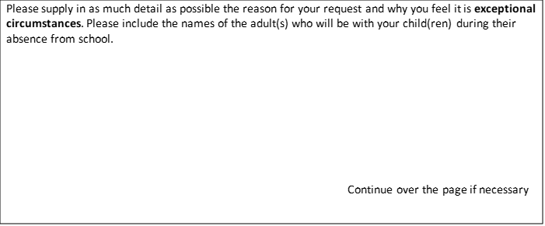

Signed (both parents if applicable)

Parent 1 …………………………………………………

Parent 2 ………………………………………………… Date……………………………………………………………

PLEASE SUBMIT ONE MONTH BEFORE THE DATE OF THE REQUEST

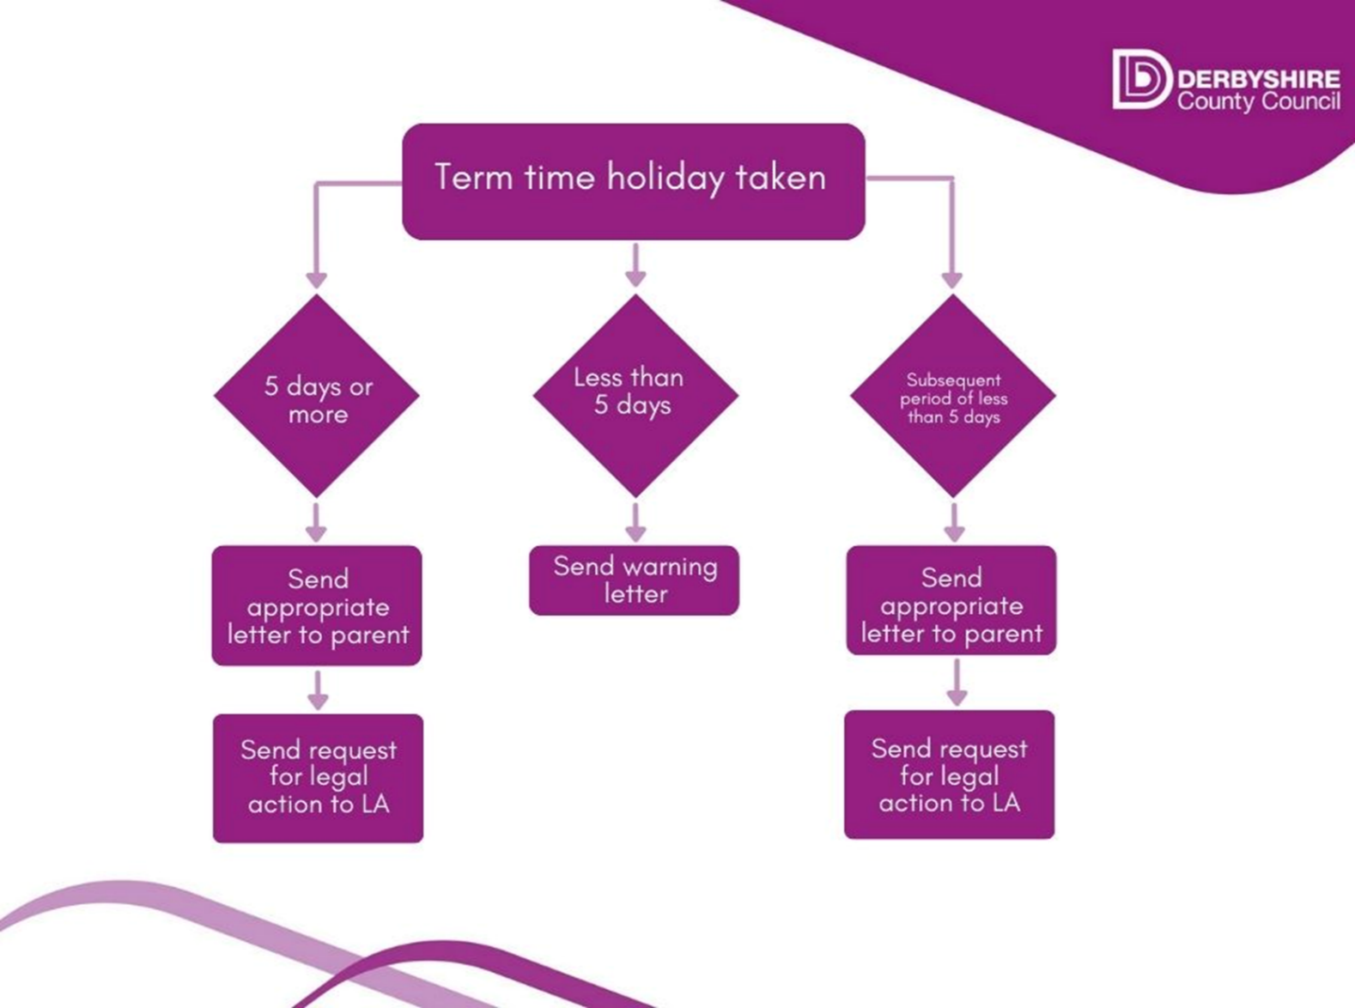
Appendix D Term Time Absence

Appendix E - Term Time Letters
5 days+
Example letter – leave approved

School Headed Paper

Recipient(s) full name

Address DATE

Dear

Absence from School

Thank you for your application requesting leave of absence for CHILD’S NAME, for NUMBER school days, from DATE to DATE, for the purpose of a family holiday.

In September 2013 the Education (Pupil Registration) (England) (Amendment) Regulations 2013 came into force. These regulations make it clear that Headteachers should not grant approval for any leave of absence during term-time, including holidays, unless there are exceptional circumstances.

Having carefully considered your application, in line with Government guidelines, I am able to grant approval for your request for NUMBER school days on the basis that the reason given is exceptional.

Yours sincerely

Example – leave request denied (unauthorised)

School Headed Paper

Recipient(s) full name

Address DATE

Dear

Absence from School

Thank you for your application requesting leave of absence for CHILD’S NAME, for NUMBER school days, from DATE to DATE, for the purpose of a family holiday.

In September 2013 the Education (Pupil Registration) (England) (Amendment) Regulations 2013 came into force. These regulations make it clear that Headteachers should not grant approval for any leave of absence during term-time, including holidays, unless there are exceptional circumstances.

Having carefully considered your application, in line with Government guidelines, I am unable to grant approval for your request as the reason given is not exceptional. If your child is absent from school during the specified dates you may be issued with a Penalty Notice for this unauthorised absence.

Please do not hesitate to contact me should you wish to discuss this matter further.

Yours sincerely

Example letter – leave unauthorised/late application

School Headed Paper

Recipient(s) full name

Address DATE

Dear

Absence from School

Thank you for your application requesting leave of absence for CHILD’S NAME, for NUMBER school days, from DATE to DATE, for the purpose of a family holiday.

In September 2013 the Education (Pupil Registration) (England) (Amendment) Regulations 2013 came into force. These regulations make it clear that Headteacher’s should not grant approval for any leave of absence during term-time, including holidays, unless there are exceptional circumstances.

Having carefully considered your application, in line with Government guidelines, I am unable to grant approval for your request as the reason given is not exceptional. In any event, as your application was received late (expand on this if necessary e.g. quote school policy or when the application was received) I was unable to advise you of my decision prior to your departure.

For your information, CHILD’S NAME absence has been marked in the register with code ‘G’ which means ‘unauthorised absence for a holiday during term-time’ and you may be issued with a penalty notice for this unauthorised absence.

Please do not hesitate to contact me should you wish to discuss this matter further.

Yours sincerely

Example letter – challenge reason for absence

School Headed Paper

Recipient(s) full name

Address DATE

Dear

Absence from School

CHILD’S NAME was absent from school for NUMBER school days between DATE and DATE. You informed SCHOOL that CHILD’S NAME was absent due to REASON.

It is my belief that CHILD’S NAME was absent from school due to a family holiday. In view of this, in accordance with Government regulation, I must mark the register for CHILD’S NAME with a ‘G’ which means ‘unauthorised absence for a holiday during term-time’.

If this is not the case please arrange an appointment to meet with me to discuss the matter further and where possible provide evidence to support your position. Unless I hear from you in the next 5 school days I will refer the case to the Local Authority and you may be issued with a penalty notice for unauthorised absence.

Please do not hesitate to contact me should you wish to discuss this matter further.

Yours sincerely

Example letter – challenge absence

School Headed Paper

Recipient(s) full name

Address DATE

Dear

Absence from School

NAME was absent from school for NUMBER days between DATE and DATE without explanation. You were sent a text message, enquiring about the reason for absence, each day during this time. (Or give details of the contacts made by school during the absence.)

It is my belief (or - You have since informed us) that CHILD’S NAME was absent from school due to a family holiday. In view of this, in accordance with Government regulation, I must mark the register for CHILD’S NAME with a ‘G’ which means ‘unauthorised absence for a holiday during term-time’.

If this is not the case please arrange an appointment to meet with me to discuss the matter further and where possible provide evidence to support your position. Unless I hear from you in the next 5 school days I will refer the case to the Local Authority and you may be issued with a penalty notice for unauthorised absence.

Please do not hesitate to contact me should you wish to discuss this matter further.

Yours sincerely

Appendix E - Term Time Letters
Less than 5 days
Example letter – leave approved

School Headed Paper

Recipient(s) full name

Address DATE

Dear

Absence from School

Thank you for your application requesting leave of absence for CHILD’S NAME, for NUMBER school days, from DATE to DATE, for the purpose of a family holiday.

In September 2013 the Education (Pupil Registration) (England) (Amendment) Regulations 2013 came into force. These regulations make it clear that Headteachers should not grant approval for any leave of absence during term-time, including holidays, unless there are exceptional circumstances.

Having carefully considered your application, in line with Government guidelines, I am able to grant approval for your request for NUMBER school days on the basis that the reason given is exceptional.

Yours sincerely

Example – leave request denied (unauthorised)

School Headed Paper

Recipient(s) full name

Address DATE

Dear

Absence from School

Thank you for your application requesting leave of absence for CHILD’S NAME, for NUMBER school days, from DATE to DATE, for the purpose of a family holiday.

In September 2013 the Education (Pupil Registration) (England) (Amendment) Regulations 2013 came into force. These regulations make it clear that Headteachers should not grant approval for any leave of absence during term-time, including holidays, unless there are exceptional circumstances.

Having carefully considered your application, in line with Government guidelines, I am unable to grant approval for your request as the reason given is not exceptional.

Whilst on this occasion we will not be requesting a Penalty Notice please note that should there be any further periods of unauthorised leave during term time regardless of the duration this may result in a request for a penalty notice

Please do not hesitate to contact me should you wish to discuss this matter further.

Yours sincerely

Example letter – leave unauthorised/late application

School Headed Paper

Recipient(s) full name

Address DATE

Dear

Absence from School

Thank you for your application requesting leave of absence for CHILD’S NAME, for NUMBER school days, from DATE to DATE, for the purpose of a family holiday.

In September 2013 the Education (Pupil Registration) (England) (Amendment) Regulations 2013 came into force. These regulations make it clear that Headteacher’s should not grant approval for any leave of absence during term-time, including holidays, unless there are exceptional circumstances.

Having carefully considered your application, in line with Government guidelines, I am unable to grant approval for your request as the reason given is not exceptional. In any event, as your application was received late (expand on this if necessary e.g. quote school policy or when the application was received) I was unable to advise you of my decision prior to your departure.

For your information, CHILD’S NAME absence has been marked in the register with code ‘G’ which means ‘unauthorised absence for a holiday during term-time.

Whilst on this occasion we will not be requesting a Penalty Notice please note that should there be any further periods of unauthorised leave during term time regardless of the duration this may result in a request for a penalty notice

Please do not hesitate to contact me should you wish to discuss this matter further.

Yours sincerely

Example letter – challenge reason for absence

School Headed Paper

Recipient(s) full name

Address DATE

Dear

Absence from School

CHILD’S NAME was absent from school for NUMBER school days between DATE and DATE. You informed SCHOOL that CHILD’S NAME was absent due to REASON.

It is my belief that CHILD’S NAME was absent from school due to a family holiday. In view of this, in accordance with Government regulation, I must mark the register for CHILD’S NAME with a ‘G’ which means ‘unauthorised absence for a holiday during term-time’.

If this is not the case please arrange an appointment to meet with me to discuss the matter further and where possible provide evidence to support your position.

Whilst on this occasion we will not be requesting a Penalty Notice please note that should there be any further periods of unauthorised leave during term time regardless of the duration this may result in a request for a penalty notice

Please do not hesitate to contact me should you wish to discuss this matter further.

Yours sincerely

Example letter – challenge absence

School Headed Paper

Recipient(s) full name

Address DATE

Dear

Absence from School

NAME was absent from school for NUMBER days between DATE and DATE without explanation. You were sent a text message, enquiring about the reason for absence, each day during this time. (Or give details of the contacts made by school during the absence.)

It is my belief (or - You have since informed us) that CHILD’S NAME was absent from school due to a family holiday. In view of this, in accordance with Government regulation, I must mark the register for CHILD’S NAME with a ‘G’ which means ‘unauthorised absence for a holiday during term-time’.

If this is not the case please arrange an appointment to meet with me to discuss the matter further and where possible provide evidence to support your position.

Whilst on this occasion we will not be requesting a Penalty Notice please note that should there be any further periods of unauthorised leave during term time regardless of the duration this may result in a request for a penalty notice

Please do not hesitate to contact me should you wish to discuss this matter further.

Yours sincerely

Appendix F – DCC Attendance Flow Chart

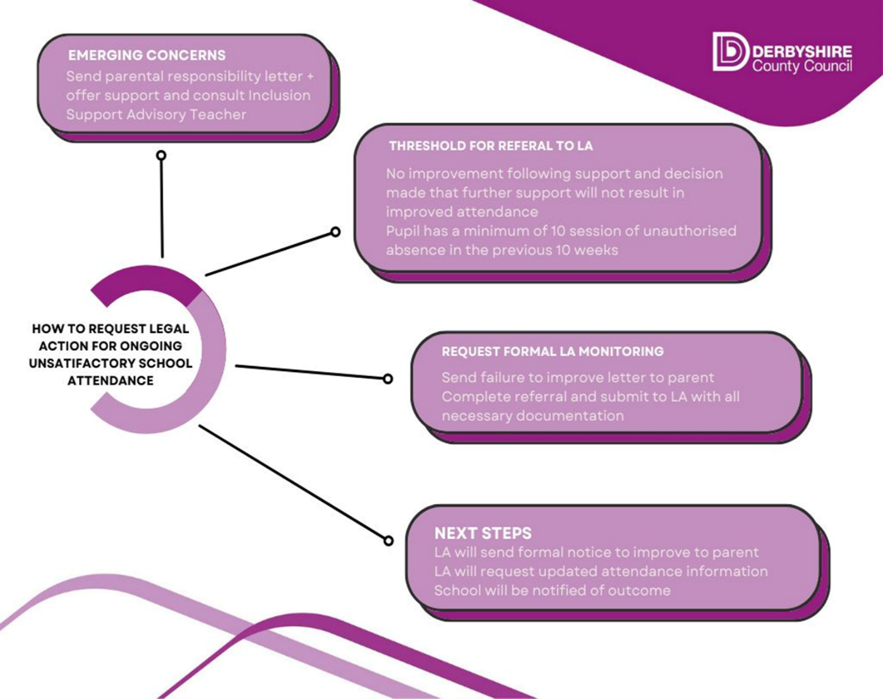

Appendix G - Fixed Penalty Notice Information
National Framework for Penalty Notices

Purpose of Penalty Notices

Penalty notices are issued to parents as an alternative to prosecution where they have failed to ensure that their child of compulsory school age regularly attends the school where they are registered or, in certain cases, at a place where alternative provision is provided. Penalty notices can be used by all schools where the pupil’s absence has been recorded with one or more of the unauthorised codes and that absence(s) constitutes an offence. A penalty notice can be issued to each parent liable for the offence or offences. They should usually only be issued to the parent or parents who have allowed the absence (regardless of which parent has applied for a leave of absence).
Penalty notices are intended to prevent the need for court action and should only be used where it is deemed likely to change parental behaviour and support to secure regular attendance has been provided and has not worked or been engaged with, or would not have been appropriate in the circumstances of the offence (e.g. an unauthorised holiday in term time).

Penalty notices must be issued in line with the Education (Penalty Notices) (England) Regulations 2007, as amended and can only be issued by a headteacher or someone authorised by them (a deputy or assistant head), a local authority officer or the police. They must also be issued in line with Local Codes of Conduct which are drawn up and maintained by each local authority.

All state funded schools must consider whether a penalty notice is appropriate in each individual case where one of their pupils reaches the national threshold for considering a penalty notice. Schools should not have a blanket position of issuing or not issuing penalty notices and should make judgements on each individual case to ensure fairness and consistency across the country.

The threshold is 10 sessions of unauthorised absence in a rolling period of 10 school weeks. A school week means any week in which there is at least one school session. This can be met with any combination of unauthorised absence (e.g. 4 sessions of holiday taken in term time plus 6 sessions of arriving late after the register closes all within 10 school weeks). These sessions can be consecutive (e.g. 10 sessions of holiday in one week) or not (e.g. 6 sessions of unauthorised absence taken in 1 week and 1 per week for the next 4 weeks). The period of 10 school weeks can also span different terms or school years (e.g. 2 sessions of unauthorised absence in the Summer Term and a further 8 within the Autumn Term)

When a school becomes aware that the threshold has been met, they are expected to make the following considerations to decide whether to issue a penalty notice in each individual case:

• Is support appropriate in this case?

If yes, schools are expected to continue with the existing support without a penalty notice or issue a Notice to Improve if that support is not working or is not being engaged with. A penalty notice can be issued if either has not worked.

If no, for example a holiday in term time, a penalty notice should be issued subject to the other conditions below.

  - Is a penalty notice the best available tool to improve attendance and change parental behaviour for this particular family or would further support or one of the other legal interventions be more appropriate?
  - Is issuing a penalty notice in this case appropriate after considering any obligations under the Equality Act 2010 such as where a pupil has a disability?
  - (For local authorities only) Is it in the public interest to issue a penalty notice in this case given the local authority would be responsible for any resulting prosecution for the original offence in cases of non-payment?

If the answer to those questions is yes, then a penalty notice should be issued. If not, another tool or legal intervention should be used to improve attendance.

Support is defined as any activity intended to improve the pupil’s attendance, not including issuing a penalty notice or prosecution. As part of this consideration, schools and local authorities should consider what suitable forms of support are currently available in school and where necessary from other services and agencies in the area. They should then decide whether any of those things are appropriate in the individual cases and for those that are appropriate, whether they have been provided previously or could be provided now instead of taking legal action. The local authority’s decision on whether sufficient support has been provided before issuing a penalty notice should be treated as final.

Whatever action is taken after the national threshold has been met, schools, and local authorities where appropriate, should monitor the impact of the action, and if it does not lead to attendance improvement review the case and consider alternative actions.

The National Framework does not prevent a penalty notice from being used in other cases where an offence has been committed but before doing so authorised officers are expected to make the same considerations as set out above. If in an individual case the local authority (or other authorised officer) believes a penalty notice would be appropriate, they retain the discretion to issue one before the threshold is met. This might apply for example, where parents are deliberately avoiding the national threshold by taking several term time holidays below threshold, or for repeated absence for birthdays or other family events. If local authorities wish to exercise this discretion to issue a penalty notice earlier in such circumstances, they should make this clear in their Local Code of Conduct. Local authorities who conduct, or may wish to, conduct truancy sweeps will also want to make provision for this within their Code.

Notices to improve

A Notice to Improve is a final opportunity for a parent to engage in support and improve attendance before a penalty notice is issued. If the national threshold has been met and support is appropriate but offers of support have not been engaged with by the parent or have not worked, a Notice to Improve should usually be sent to give parents a final chance to engage in support. A Notice to Improve does not need to be issued in cases where support is not appropriate and an authorised officer can choose not to use one in any case, including cases where support is appropriate but they do not expect a Notice to Improve would have any behavioural impact (e.g. because the parent has already received one for a similar offence).

Where a Notice to Improve is used, it should be issued in line with processes set out in the Local Code of Conduct for the local authority area in which the pupil attends school.

The Notice to Improve is expected to include:
  - Details of the pupil’s attendance record and details of the offences.
  - The benefits of regular attendance and parents’ duty under section 7 of the Education Act 1996.
  - Details of the support provided so far.
  - Opportunities for further support and the option to access previously provided support that was not engaged with.
  - A clear warning that a penalty notice may be issued or prosecution considered if attendance improvement is not secured within the improvement period.
  - A clear timeframe for the improvement period of between 3 and 6 weeks.
  - Details of what sufficient improvement within that timeframe will look like.
  - The grounds on which a penalty notice may be issued before the end of the improvement period.

What sufficient improvement looks like can be decided on a case by case basis taking the individual family’s circumstances into account. For some families, no further
unauthorised absences will be appropriate, for others some absence may be tolerable if considerable improvement is seen. Details of what sufficient improvement for each case should be made clear in the Notice to Improve.

Where it is clear that improvement is not being made, it may be appropriate to issue a penalty notice before the improvement period has ended. For example, a Notice to Improve stated there should be no further unauthorised absences in a 6 week period but the pupil is absent for unauthorised reasons in the first week. The parent should be informed before a penalty notice is issued if it is before the end of the improvement period.

Two penalty notice limit and escalation in cases of repeat offences

A penalty notice is an out of court settlement which is intended to change behaviour without the need for criminal prosecution. If repeated penalty notices are being issued and they are not working to change behaviour they are unlikely to be most appropriate tool. Therefore, from autumn term 2024, only 2 penalty notices can be issued to the same parent in respect of the same child within a 3 year rolling period and any second notice within that period is charged at a higher rate:
  - The first penalty notice issued to a parent in respect of a particular pupil will be charged at £160 if paid within 28 days. This will be reduced to £80 if paid within 21 days.
  - A second penalty notice issued to the same parent in respect of the same pupil is charged at a flat rate of £160 if paid within 28 days.
  - A third penalty notice cannot be issued to the same parent in respect of the same child within 3 years of the date of issue of the first. In a case where the national threshold is met for a third time (or subsequent times) within those 3 years, alternative action should be taken instead. This will often include considering prosecution, but may include other tools such as one of the other attendance legal interventions.

Once 3 years has elapsed since the first penalty notice was issued a further penalty notice can be issued, but in most cases it would not be the most effective tool for changing what may have now become an entrenched pattern of behaviour.

For the purpose of the escalation process, previous penalty notices include those not paid (including where prosecution was taken forward and the parent pleaded or was found guilty) but not those which were withdrawn.

In cases where a pupil has moved school or local authority area in the previous 3 years an additional check should be made to try and ascertain whether previous penalty notices have been issued to the parent in respect of the pupil. Where the pupil’s previous school was in the same local authority area this check will be simple. If the pupil has moved between local authorities in the previous 3 years and the previous local authority(ies) is known they should be contacted to check whether a penalty notice has been issued to that parent for that pupil in the previous 3 years. These checks can be made by the school and/or local authority depending on the agreed local process. In cases where the previous local authority is not known or the information cannot be, or is not, provided by the previous local authority, it should be assumed that the parent has not previously received a penalty notice and the escalation process started as a new case.

Appendix H – Request to LA for formal commencement of statutory parental responsibility measures/legal action in relation to school attendance


Request to LA for formal commencement of statutory parental responsibility measures/legal action in relation to school attendance.
(One request form per child)

The following information must be provided before the Attendance Team can consider serving a Penalty Notice/prosecution. Should the case forwarded for prosecution this information will be used as evidence, in court under section 444 of the Education Act 1996.

D.C.C. USE ONLY:

Sch. code:

PRN:

Parent 1 ref:

Parent 2 ref:

Name of School

Pupil information
Forename Surname DOB

Address including
Check the address is correct before submitting to the LA. If incorrect the school will be named as the data breach source

postcode

Dates that the pupil was absent from school

(e.g. 16/05/2011 to 25/05/2011 inclusive.

Parent 1* for whom Penalty Notice is being requested
Title Forename Surname

Check the address is correct before submitting to the LA. If incorrect the school will be named as the data breach source

Address including
postcode, if different
from pupil

Parent 2* for whom Penalty Notice is being requested
Title Forename Surname

Check the address is correct before submitting to the LA. If incorrect the school will be named as the data breach source
source

Address including

postcode, if different
from pupil

PLEASE COMPLETE THE RELEVANT SECTION BELOW FOR EITHER UNAUTHORISED LEAVE IN TERM TIME OR UNSATISFACTORY SCHOOL ATTENDANCE
UNAUTHORISED LEAVE TAKEN IN TERM TIME

A copy is required of each of the following documents:
Please tick appropriate box to indicate copy is attached to this form.

- Leave of Absence Request Form completed by parent/carer *

- Letter from school to each parent indicating that leave would not be authorised or
a challenge letter *

- Attendance report (herringbone) for the current academic year showing 10 sessions of absence
(5 days) marked as absence code G *

- Copy of statement in school prospectus/newsletter warning of consequences of taking leave
In term time that has not been authorised *

Requests must be submitted within 4 weeks of the end of the period of unauthorised leave

UNSATISFACTORY SCHOOL ATTENDANCE

A copy is required of each of the following documents:
Please tick appropriate box to indicate copy is attached to this form.

- Copy of the parental responsibility letter *
- A full chronology of support provided to parents(s) over the last 6 months *
- Copy of attendance printout for the last 12 months showing 10 sessions of unauthorised *
absence in the previous 10-week period.

- An explanation for the use of any registration codes other than /\ and O: *

Requests must be submitted as soon as the threshold has been reached

Head Teacher’s signature _________________________________ Date _____________

Please send all this information within 4 weeks of the end of the unauthorised leave taken in term time or within 10 days of the end of the monitoring period via perspective lite to EWS_830school 4 digit DFE No: pnholchild initials & date backwards or EWS_830school 4 digit DFE No:pnattchild initials & date backwards for example:-EWS_8301000pnattjb20240514 or EWS_8301000pnholjb20240514

If you have any queries regarding Penalty Notices please do not hesitate to contact the Attendance Process Team on 01629 532157 or email CS.AttendanceProcessTeam@derbyshire.gov.uk

