Maths:
Fractions, decimals and percentages:
- round decimals with one decimal place to the nearest whole number;
- recognise and show, using diagrams, families of common equivalent fractions;
- recognise fraction and decimal equivalence ¼ , ½ , ¾
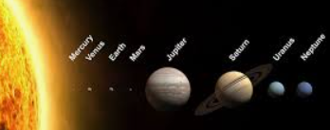
Out of this World Year 4 topic map
Links to Federation Aims and Values:
To provide them with a dynamic and relevant curriculum with new and exciting values providing positive challenge and experiences.
Art: 3D Design – Aliens 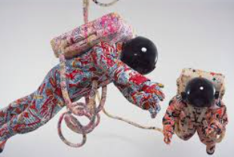
- Learn about great artists (Yinka Shonibare)
- Transferring 2D shape and texture to 3D form
- Creating Batik inspired patterns

RE: Key Question U2.6 What does it mean to be a Muslim in Britain today?
Key Question U2.7 What matters most to Christians and Humanists?
French:
Introducing the planets
Design and Technology: Mechanical systems, pneumatics:
Design and make a space alien toy
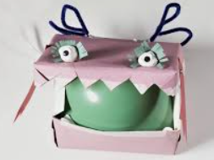
English: Book Study: Cosmic by Frank Cottrell Boyce
Insert dialogue into longer stories.
Use inference and deduction when studying texts. 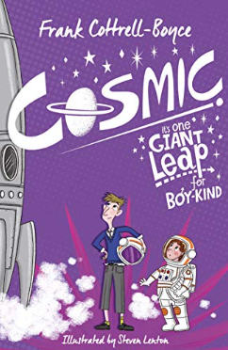

Geography: Land use and settlement
Describe and understand key aspects of human geography, including: types of settlement and land use, economic activity including trade links, and the distribution of natural resources including energy, food, minerals and water.
PE:
Gymnastics or dance
Hockey
PSHE:
Difference and Diversity
Recognising the differences and similarities between people, but understand that everyone is equal.
Being Responsible
Explore rights and responsibilities, rights and duties at home, school, community, and the environment.

Music:
Young Voices concert
The Pink Panther theme
Twinkle, twinkle little star
Rocks: 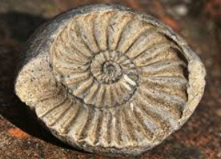
- Comparing and grouping rocks based on their appearance and physical properties
- Describing how fossils are formed
- Recognising that soils are made from rocks and organic matter.

Computing: Develop their understanding of what a branching database is and how to develop one.
Key Vocabulary:
Hot: nebula, inertia, equinox, heliocentric, binary star, penumbra,
Medium: magnitude, meteoroid, meteorite, cosmonaut, cosmos, density, asteroid, elliptical orbit, comet, asteroid, astronomy, observatory, zodiac, crescent, waxing, constellation, solstice, waning, latitude, expanse, galaxy, gibbous,
Go: rocket, mass, dust, illuminate, astronaut, atmosphere, journey, gravity, movement, telescope

