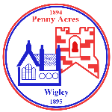
Federation of Penny Acres and Wigley Primary Schools – Topic Map
Reception/KS1 – Super Toys

Curriculum driver(s) -  English/History/Computing |  | Aims/Values drivers (taken from school’s key aims/values)  - To encourage all parents and carers to play a positive and active role in the education of their children by forging meaningful relationships.  - To instil in the children the key skills and attitudes necessary for them to become motivated and independent learners, leaders and co-operative team players
Child Interest
Super heroes
My favourite toys
Key Question drivers –  What are toys made from? What is my favourite toy and why? What adventures might they have when I am asleep? Were toys different in the past? |  | Authentic Outcome –  Supertato/ super veg animations and adventure stories presentation
Hook/Visits/Visitors  Heritage Doncaster Workshop- Timeline of Toys  Bring in a toy day |  | Role play Opportunities  Super Hero HQ
English
Rec ELG’s: Fine Motor Skills/Comprehension/ Reading & Writing

Reading (including key texts) | Writing Opportunities |  | Spelling and Grammar
Rec/Y1/2  Supertato  Toys in Space  Dogger  Hermelin the Detective Mouse  Top Top Secret  Newspaper Girl & Origami Boy  Lost in the Toy Museum  Kipper's Toy Box  Where’s My Teddy?  Toy Story | Rec/Y1/2  - Character descriptions- super veg/Toy Story characters  - Write about your favourite to  - Working on Nouns and Adjectives- Toy Story Characters  - Instructions- how to fix Woody  - Speech bubbles for characters-different types of sentences  - Lost posters  - Planning and writing stories about a lost toy (based on Where’s My Teddy or Dogger) |  | Rec/Y1/2  Follow Sound Discovery for daily phonics.  Y1/2  Identify & use adjectives.  Verbs- past tense. Spelling verbs with ed correctly.  Write expanded noun phrases.  Use capital letters, spaces between words and full stops accurately & consistently.  Maintain the present or past tense throughout a piece of writing.  Imperative verbs
Tiered vocabulary | 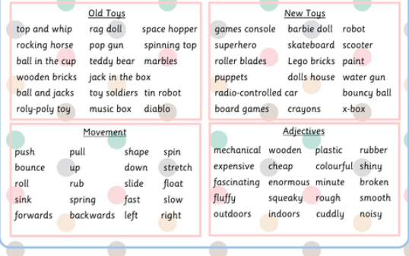
Numeracy

Rec: Count objects, actions and sounds. Subitise. Compare amounts. Continue, copy and create repeating patterns. Compare length, weight and capacity.
Key Vocabulary:
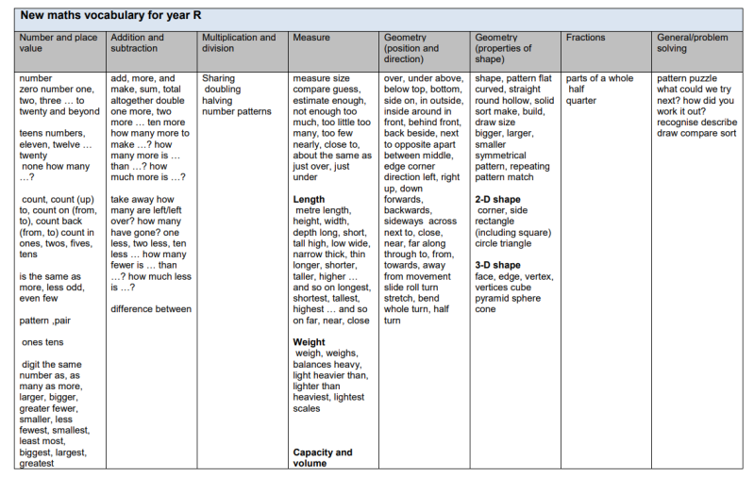

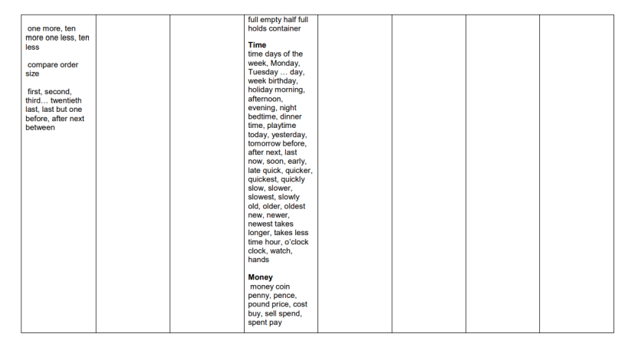
Y1: Number/Place Value: Count to 10, forwards and backwards, beginning with 0 or 1, or from any given number. Count, read and write numbers to 10 in numerals. Given a number, identify one more and one less (within 10) Identify and represent numbers using objects and pictorial representations including the number line, and use the language of: equal to, more than, less than (fewer), most, least.
Read and write numbers from 1 to 10 in numerals and words.
Y1: Addition & Subtraction: Read, write and interpret mathematical statements involving addition (+), subtraction (–) and equals (=) signs. Represent and use number bonds and related subtraction facts within 10. Add and subtract numbers to 10, including zero.
Solve one-step problems that involve addition and subtraction, using concrete objects and pictorial representations, and missing number problems such as 7 = – 9.

Key Vocabulary:
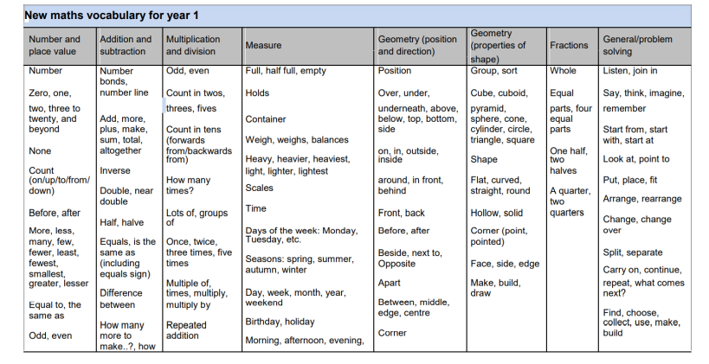

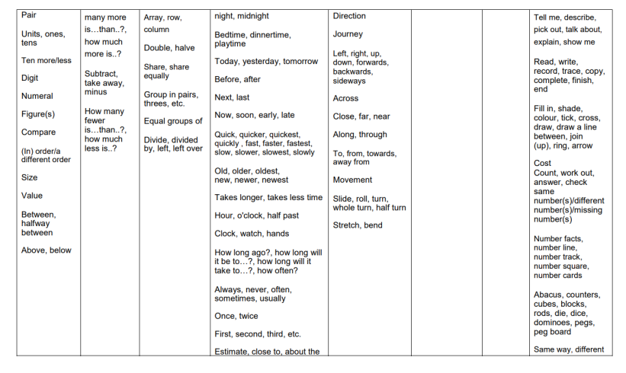

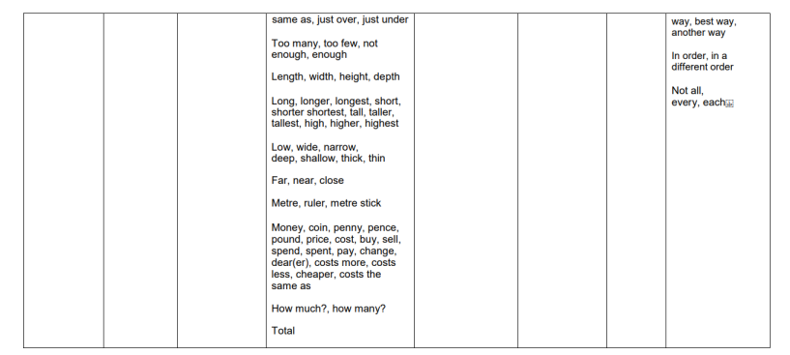
Y2: Number/Place Value: Count in steps of 2, 3, and 5 from 0, and in tens from any number, forward and backward. Recognise the place value of each digit in a two-digit number (tens, ones) Identify, represent and estimate numbers using different representations, including the number line. Compare and order numbers from 0 up to 100; use and = signs. Read and write numbers to at least 100 in numerals and in words. Use place value and number facts to solve problems.
Y2: Addition and Subtraction
Solve problems with addition and subtraction by: using concrete objects and pictorial representations, applying their increasing knowledge of mental and written methods, recall and use addition and subtraction facts to 20 fluently, and derive and use related facts up to 100. Add and subtract numbers using concrete objects, pictorial representations, and mentally, including: a two-digit number and ones and tens, two two-digit numbers, three one-digit numbers. Show that addition of two numbers can be done in any order (commutative) and subtraction of one number from another cannot. Recognise and use the inverse relationship between addition and subtraction and use this to check calculations and solve missing number problems.

Key Vocabulary:

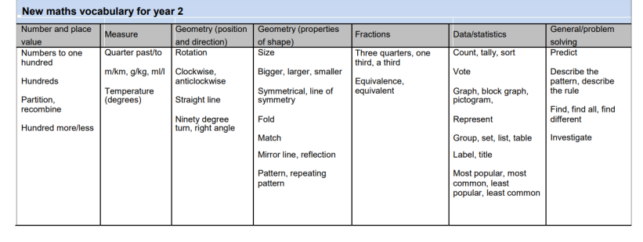
Science
(Key Vocabulary and links to programmes of study)
Rec ELG: The Natural World
Rec: Explore the natural world around them. Describe what they see, hear and feel whilst outside.

Every day Materials (Y1 PoS)
Distinguish between an object and the material from which it is made.
Identify and name a variety of everyday materials, including wood, plastic, glass, metal, water, and rock.
Describe the simple physical properties of a variety of everyday materials.
Compare and group together a variety of everyday materials on the basis of their simple physical properties.
Activities:
- Identify & name everyday materials through video clip https://www.bbc.co.uk/bitesize/topics/zrssgk7/articles/z6jm7yc & PPT (tes)
- Sort a variety of objects into material sets e.g. objects made from glass/plastic/wood etc
- Children complete a simple table in books- object/material it is made from or draw a selection of the objects & label them.
- https://www.bbc.co.uk/bitesize/articles/z2bdjxs What material is it made from?
- Use PPT to introduce/recap natural & man-made materials & material properties- find out which materials are man made/ which are natural.
- Help the children create a ‘treasure chest’ using an egg box and find treasures that match the adjectives inside e.g. rigid, shiny, dull, flexible, transparent, opaque etc
- Explore forces ‘push and pull’. How can you make your car move? Ramp experiments.
- Have a ‘Lucky Dip’ of toys & encourage children to describe what they have found & see if the rest of the group can guess the toy from the picture sheet. Vocab- bendy, bumpy, dull, feel, hard, made, manufactured, material, natural, rough, shiny, smooth, soft, squashy, stiff, stretchy.
- Explore a collection of materials & investigate those that are attracted to a magnet. Vocab- attract, attracted, magnet, magnetic, material, metal, not attracted, not magnetic, pick up, stick.
- Investigate the best material to make a towel. Do a simple test & record what we did & the results. Vocab- cloth, cotton, material, nylon, soak, terry towelling, towel, water, wool, absorbent.
- Discuss the difference between a mirror & a window. What makes a mirror reflective? Discuss why we can sometimes see our reflection in windows. Children explore & record how they can turn a window into a mirror. Vocab- dark, glass, light, material, mirror, pane, Perspex, reflect, reflection, shiny, smooth, window.
Computing
(Key Vocabulary and links to programmes of study)
Y1/2: Use technology purposefully to create, organise, store, manipulate and retrieve digital content. Recognise common uses of information technology beyond school.
Activities:
- Animated story books unit 1.6 Purple Mash- Children create their own animated story book using 2Create a Story.
Key Vocab: animation, e-book, sound effect, font, file, save, display board.
Geography/History
(Key Vocabulary and links to programmes of study)
Rec ELG: People, Culture & Communities.
Rec: Comment on images of familiar situations in the past.
Y1/2: History
Develop an awareness of the past, using common words and phrases relating to the passing of time. Identify similarities and differences between ways of life in different periods.
Use a wide vocabulary of everyday historical terms- Rec: today, yesterday, tomorrow, the present, the past, the future, day, week, month, long ago, old, new, recent, parent, grand parent, great grand parent, clue, memory, life time, calendar, Who? What? materials, plastic, remember. Year 1: year, decade, century, ancient, modern, long ago, time line, date order, similar, different, important, living memory, 1960s, toys, materials, wood, plastic, simple, mechanical, inventions, homes, houses, grandparents time, the older generation, memories, drawing, photograph, camera, detective, opinion, artefact, What?, When?, Where? Year 2: anachronism, era, period, chronological order, the Tudors, the Stuarts, the Victorians, investigate, evidence, research, Why?, historians, experts, letters, newspapers, websites, opinion, artefact, What?, When?, Where?
Understand some of the ways in which we find out about the past and identify different ways in which it is represented.
Changes within living memory (toys and games)
Key Questions/Activities:
- What are our toys like? Children bring a favourite toy into school to talk about. They draw, label & describe what makes their toy a ‘new’ toy.
- What were our parents & grandparent’s toys like? Ask the children to talk to a parent or grandparent about the toys they had when they were small. Have a look at real toys or photos- discuss & compare. Children choose one of the toys to draw & describe.
- http://resources.hwb.wales.gov.uk/VTC/how_toys_change/eng/Introduction/default.htm
- Create a toy timeline.
- What toys did the Victorians play with? Show artefacts e,g, cup & ball, spinning top, skipping ropes. Discuss the toys & play with them & compare with our new toys. Children draw their favourite Victorian toy and describe it & explain why they enjoyed playing with it. Discuss what we can find out about the past from these toys e.g. no electrical toys, materials, colour.
- https://www.bbc.co.uk/bitesize/topics/zj3nf82/articles/z8x7m39
- What moving toys did children play with in the Victorian times? Look at rocking horse, pull along toys, puppets. Look at what they are made of & discuss how we can make them move.
- What playground games did Victorian children play? Make a list of games the children play today. Find out about playground games from the Victorian times. Listen to skipping rhymes etc & discuss what the words mean e.g. Muffin Man, Jack jump over the candle stick, Hippety hopping to the corner shop to buy a stick of candy, etc.
- The first teddy bear. Children bring in their own teddy bear & find out about the invention of the teddy bear & where the name came from. Read the story about President Roosevelt & his hunting trip. Children create a poster advertising the first ever teddy bear- include pictures & captions showing the President & the bear. Introduce children to Steiff bears.
- What is the same & what is different? Show 2 toys of the same type e.g. 2 teddies, 2 puppets or 2 moving cars. Discuss what is the same/different & how they have changed. Encourage the children to look at design, materials, how they move, colour etc. Children draw both toys and write a description comparing them using word bank.
RE/PSHE/Modern British Values
(Key Vocabulary and links to programmes of study)
Rec ELG’s for PSE Development/People, Culture & Communities
PSHE (PSHE Matters) Module 2- Exploring emotions
R1 – Recognising a range of feelings in ourselves and other people.
R1 – Recognising how others show feelings and how to respond.
R2 – Recognising that their behaviour can affect others.
H1 – Communicating feelings to others.
H4 – Developing simple strategies for managing feelings.
H4 – Using words to describe a range of feelings.

R.E (Derbyshire Syllabus)
Rec: Recognise that people have different beliefs and celebrate special times in different ways. Understand that some places of special to members of their community.
Y1/2: Key Question: 1.4 What can we learn from sacred books?
Recognise that sacred texts contain stories which are special to many people and should be treated with respect.
Re-tell stories from the Christian Bible and stories from another faith; suggest the meaning of these stories.
Ask and suggest answers to questions arising from stories Jesus told and from another religion.
Talk about issues of good and bad, right and wrong arising from the stories.
Activities:
- Explore what a story is and why we like them; are there different types of story? Introduce a parable as a story with a deeper meaning. Talk about how some books are more than special – they are sacred or holy, meaning that people believe that they are from God.
- Introduce the Bible as a sacred text for Christians, a sacred text for Muslims – Holy Qur’an, and for Jewish people – Tenakh. Investigate how these books are used and treated – Torah (part of Tenakh): often read from scrolls in the synagogue, beautifully written in Hebrew; Bible translated into lots of different versions to make accessible to all; Holy Qur’an kept in its original Arabic, as Muslims believe that is how it was revealed to Prophet Muhammad.
- Read and ask the children to illustrate & retell some stories Jesus told about what God is like (e.g. ‘The lost sheep/Lost coin’ Luke 15) and how to treat each other (e.g. ‘The good Samaritan’ Luke 10).
- Read & talk about stories from the Jewish sacred text, the Tenakh, which teach about God looking after his people e.g. ‘Joseph and his brothers’ (Genesis 37, 39–48); the story of Moses (book of Exodus); ‘The call of Samuel’ (1 Samuel 3); ‘David and Goliath’ (1 Samuel 17); Jonah (Book of Jonah).
- Explore stories about Prophet Muhammad (e.g. ‘Muhammad and the hungry stranger’, ‘The thirsty camel’, ‘The sleeping cat’, ‘Muhammad and Bilal’, ‘Muhammad and the rebuilding of the Ka’aba’).
- Share an example of a story that occurs in more than one sacred text e.g. the story of Noah, which is sacred to Muslims, Jews and Christians.
Art & Design/Design & Technology
(Key Vocabulary and links to programmes of study)
Rec ELG: Creating with Materials/Fine Motor Skills
Rec: Explore, use & refine a variety of artistic effects to express their ideas & feelings. Return to & build on their previous learning, refining ideas & developing their ability to represent them. Create collaboratively, sharing ideas, resources & skills.

Y1/2: Design & Technology: Mechanisms- Wheels & axles. Design and create a push/pull toy.
- Generating ideas based on existing products
- Use a design criterion
- Sketch and model ideas
- Describe uses and users
- Joining materials, cutting and shaping,
- Evaluating
- Exploring wheels and axles
Music
(Key Vocabulary and links to programmes of study)
Rec ELG: Being Imaginative & Expressive
Rec: Sing in a group or on their own, increasingly matching the pitch & following the melody. Listen attentively, move to & talk about music, expressing their feelings & responses.
Y1/2: Use voices expressively & creatively by singing songs & speaking chants & rhymes.
- Penny Acres- Singing Stars Tuesdays 9.15-10.30
PE
(Key Vocabulary and links to programmes of study)
Rec ELG: Gross Motor Skills
Rec: Revise & refine the fundamental movement skills already acquired. Progress towards a more fluent style of moving, with developing control & grace. Develop overall body strength, coordination, balance & agility needed to engage successfully with future PE sessions & other physical disciplines. Combine different movements with ease & fluency.
Confidently & safely use a range of large & small apparatus indoors & outside, alone & in a group. Further develop & refine a range of ball skills. Develop confidence, competence, precision & accuracy when engaging in activities that involve a ball.
Y1/2:

Homework Opportunities

- Find out from parents and grandparents about their favourite toys from when they were children.
- Make a game to play with family or friends.
- Design a super hero and describe their skills.

