At The Ballet
3 beats in a bar |  |  |  | Violin |  |  |  |  | Vamoosh
D | D | 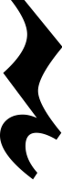 | D |  | D |  | D | D |  | D | D
A | A |  | A |  | A |  | E | E |  | E | A
D | D |  | D |  | D |  | D | D |  | D | D
A | A |  | A |  | A |  | A | A |  | A | D

