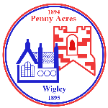
Federation of Penny Acres and Wigley Primary Schools – Topic Map
Reception/KS1 – Magic and Mystery

Curriculum driver(s) -  English/History |  | Aims/Values drivers (taken from school’s key aims/values)  To provide a dynamic and relevant curriculum; one which serves to inspire the children and prepares them for the challenges of life and citizenship in the 21st Century.  To instil in the children the key skills and attitudes necessary for them to become motivated and independent learners, leaders and co-operative team players.
Child Interest
Castles
Unicorns and dragons
Fairies

Key Question drivers –  What fairy tales do we know?  Who lived in castles long ago? |  | Authentic Outcome –  To create our own class magical story book- take your own photographs to add to the book. (word processed)
Hook/Visits/Visitors  Castle day trip - Conisbrough Castle May 16th |  | Role play Opportunities  Big boxes and medieval dressing up
English
Rec ELG’s: Fine Motor Skills/Comprehension/ Reading & Writing

Reading (including key texts) | Writing Opportunities |  | Spelling and Grammar
Rec/Y1/2  The Dragon Machine  Twelve Dancing Princesses  George and the Dragon  The Paper Bag Princess  The Tough Princess  The Princess and the Pea  The Frog Prince  The Magician’s Map  The Magic Paintbrush  The Magic Potions shop  George’s Marvellous Medicine  The Mystery of the Missing Cake | Rec/Y1/2  Explore traditional tales- identify main features and their structure e.g. story openings, middle/beginning/end, characters- goodie/baddie, story language & time connectives.  Retell traditional tales and create our own (using story dice idea)  The Princess and the Pea- write a wanted poster for a princess with a character description.  Write a factual recount of our castle trip.  Writing predictions- what could happen next? |  | Rec/Y1/2  Follow Sound Discovery for daily phonics.  Y1/2  Explore adjectives, verbs an adverbs.  Write expanded noun phrases.  Use subordinating & coordinating conjunctions.  Identify sentences of different forms.  Understand how to use question marks, exclamation marks, full stops, commas in lists and apostrophes for possession.  Spell words with suffixes and learn and apply spelling rules.  Maintain the correct tense throughout a piece of writing.
Tiered vocabulary | transform element of surprise wonder unknown enchanted mysterious wonderful puzzling vivid portal lair island gargoyle cryptic vanish disappear appear bewildered amazed
Tiered vocabulary | Magic magical mystery mysterious palace powerful spell marvellous potion fantasy
Tiered vocabulary | Castle troll witch magician giant unicorn maze clues
Numeracy

Rec: Number and Shape.
Count beyond ten. Explore and represent patterns within numbers up to 10, including evens and odds, double facts and how quantities can be distributed equally (ELG) Select, rotate and manipulate shapes to develop spatial reasoning skills. Compose and decompose shapes so that children recognise a shape can have other shapes within it, just as numbers can. Explore the composition of numbers to 10. Automatically recall number bonds for numbers 0–5 and some to 10.

Key Vocabulary: turn, rotate, sequence, pattern, even, odd, doubles, equal, same as, 2D shapes- square, triangle, rectangle, circle. 3D shapes, cube, cuboid, cylinder.
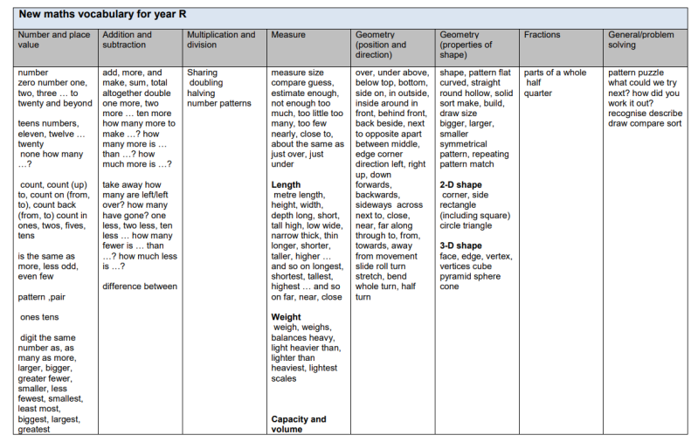

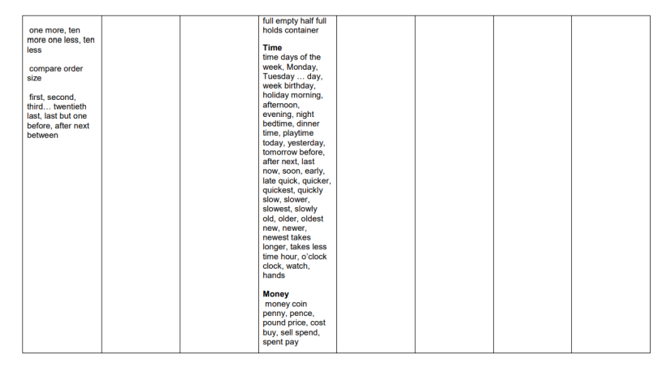
Y1: Addition & Subtraction.
Read, write and interpret mathematical statements involving addition (+), subtraction (–) and equals (=) signs. Represent and use number bonds and related subtraction facts within 20. Add and subtract numbers to 20, including zero. Solve one-step problems that involve addition and subtraction, using concrete objects and pictorial representations, and missing number problems.
Number/Place Value.
Count to 50, forwards and backwards, beginning with 0 or 1, or from any given number. Given a number, identify one more and one less (within 50) Identify and represent numbers using objects and pictorial representations including the number line, and use the language of: equal to, more than, less than (fewer), most, least. Read and write numbers from 1 to 50 in numerals.

Key Vocabulary: tens, units, less, more, compare, same as, more than, less than, 2 more, 3 more etc. 2 less, 4 less etc.
add, more than, plus, subtract, take away, less than, equals, number line, number square, one more, one less, ten more, ten less.
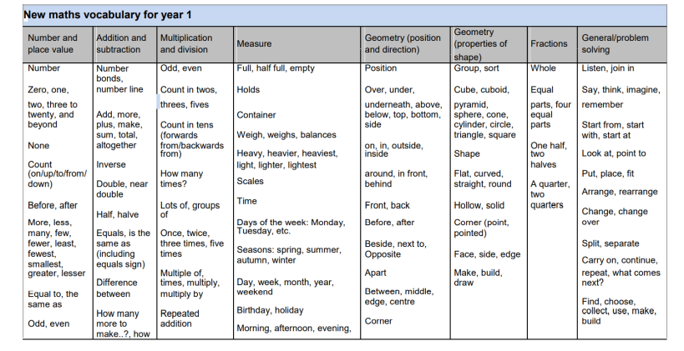

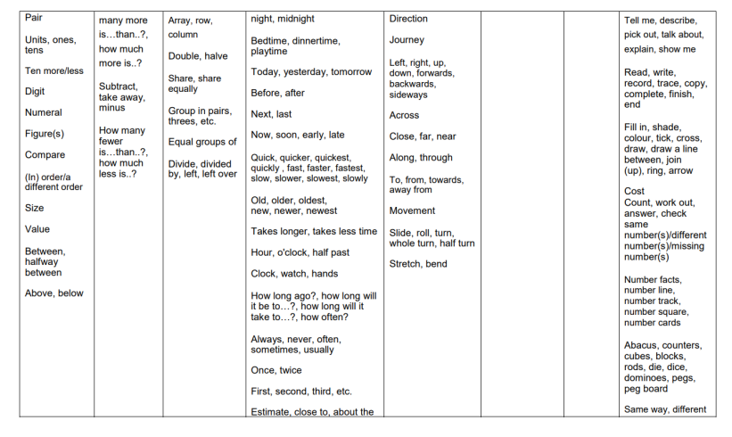

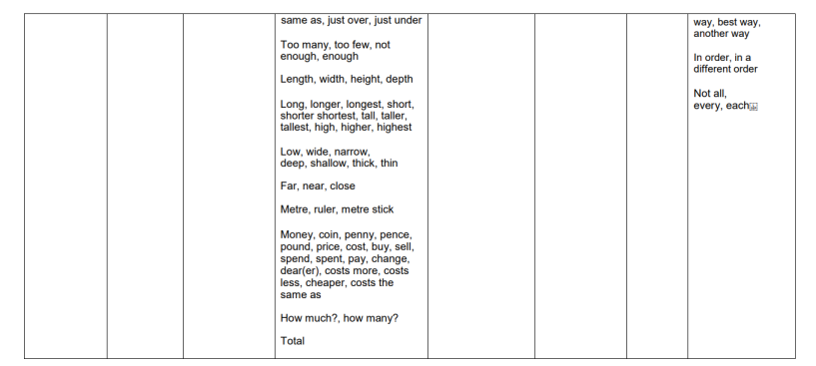
Y2: Statistics
Interpret and construct simple pictograms, tally charts, block diagrams and simple tables. Ask and answer simple questions by counting the number of objects in each category and sorting the categories by quantity and total and compare categorical data.
Measurement
Choose and use appropriate standard units to estimate and measure length/height in any direction (m/cm) Compare and order lengths/ heights. Compare and sequence intervals of time including the number of minutes in an hour and hours in a day. Choose and use appropriate standard units to estimate and measure mass (kg/g); temperature (°C); capacity (litres/ml). Compare and order mass, volume/capacity.
Geometry – Position and Direction
Order and arrange combinations of mathematical objects in patterns and sequences.
Use mathematical vocabulary to describe position, direction and movement, including movement in a straight line and distinguishing between rotation as a turn and in terms of right angles for quarter, half and three-quarter turns (clockwise and anticlockwise).

Key Vocabulary: Table, graph, pictogram, same, different, sort, vote, list, set, tally marks, total, more, less, represent, most popular, least popular.
length, height, width, cm, m, equivalent, measure, longer than, shorter than, units, time, hours, minutes, seconds, grams, kilograms, heavy, light, lighter, heavier, compare.
Sequence, pattern, repeated.
Direction, movement, forward, backwards, left, right, clockwise, anti-clockwise, quarter turn, half turn, three-quarter turn.

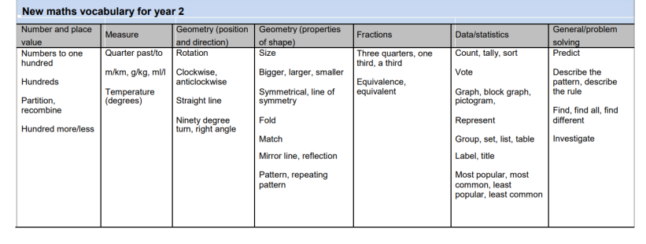
Science
(Key Vocabulary and links to programmes of study)
Rec ELG: The Natural World
Rec: Explore the natural world around them. Describe what they see, hear and feel whilst outside.
During years 1 and 2, children will be taught to use practical scientific methods, processes and skills through the teaching of the programme of study content:
Plants (Y1 & Y2 PoS) Identify and describe the basic structure of a variety of common flowering plants, including trees.
Observe and describe how seeds and bulbs grow into mature plants.
Animals (Y2 PoS)
Notice that animals, including humans, have offspring which grow into adults.

Activities: Observe the life cycle of the frog- set up an area to observe tadpoles with supporting resources including books. Children sequence and describe the life cycle.
Look at plants including trees around school. Identify the parts of a plant and find examples. Children to label the parts of a plant. Plant peas/ create a cress head and look after them.
Computing
(Key Vocabulary and links to programmes of study)
Y1/2: Understand what algorithms are; how they are implemented as programs on digital devices; and that programs execute by following precise and unambiguous instructions.
Create and debug simple programs.
Use logical reasoning to predict the behaviour of simple programs.

Activities:
Learning- What is an algorithm? Look at Coding commands.
Programming Beebots, writing instructions, executing these instructions. Magic Muddle Potions.
Purple Mash- creating step-by-step instructions.

Geography/History
(Key Vocabulary and links to programmes of study)
Rec ELG: People, Culture & Communities.
Y1/2: History
Significant historical events, places and people in their locality (Conisborough Castle)

Activities: Visit Conisborough Castle and learn about the history of the castle.
What was daily life like at Conisbrough Castle? Explore the lives of the people who lived and worked there. Children to have hands on experience investigating artefacts from the past, to discover what life was like in a medieval castle.
Why was a Castle built at Conisbrough? Explore the magnificent Keep and Bailey and learn about why Conisbrough was a significant location. Using enquiry skills, pupils will interpret evidence and discover the function and role of the castle, including the lives of past residents.

RE/PSHE/Modern British Values
(Key Vocabulary and links to programmes of study)
Rec ELG’s for PSE Development/People, Culture & Communities
R.E (Derbyshire Syllabus)
Rec: Recognise that people have different beliefs and celebrate special times in different ways.
Understand that some places are special to members of their community.
Y1/2: Key Question: 1.1 Who is a Christian and what do they believe?
Talk about some simple ideas about Christian beliefs about God and Jesus.
Re-tell a story that shows what Christians might think about God, in words, drama and pictures, suggesting what it means.
Talk about issues of good and bad, right and wrong arising from the stories.
Ask some questions about believing in God and offer some ideas of their own.

What features would I see in a church?

PSHE (PSHE Matters) Module 11- Relationships
Art & Design/Design & Technology
(Key Vocabulary and links to programmes of study)
Rec ELG: Creating with Materials/Fine Motor Skills
Rec: Explore, use and refine a variety of artistic effects to express their ideas and feelings. Return to and build on their previous learning, refining ideas and developing their ability to represent them. Create collaboratively, sharing ideas, resources and skills.
Y1/2: DT- Textiles – Templates and Joining Techniques – Make a purse or wallet for a prince or princess.
- Generating ideas based on existing products
- Use a design criterion
- Sketch and model ideas
- Describe uses and users
- Joining materials, cutting and shaping, - Evaluating
- Measuring and joining textiles
- Choosing textiles based on their properties
- Creating 3D textile structures from 2D shapes

Music
(Key Vocabulary and links to programmes of study)
Rec ELG: Being Imaginative & Expressive
Y1/2: Play tuned and untuned instruments musically.
Experiment with, create, select and combine sounds using the inter-related dimensions of music
Activities: Play the recorder. BBC Teach Traditional Tales music unit.
PE
(Key Vocabulary and links to programmes of study)
Rec ELG: Gross Motor Skills
Rec- Confidently and safely use a range of large and small apparatus indoors and outside, alone and in a group. Develop overall body-strength, balance, co-ordination and agility. Revise and refine the fundamental movement skills they have already acquired: • rolling • crawling • walking • jumping • running • hopping • skipping • climbing
Y1/2 P.E
Master basic movements including running, jumping, throwing and catching, as well as developing balance, agility and co-ordination, and begin to apply these in a range of activities including Team Games.
Homework Opportunities

- Create a storytelling box using different items e.g. dragon, magic wand. What could be inside your box? Tell a story using these character/props. What is the setting of your story?
- Create your own mythical creature with moving parts. Plan your design and then create your design.
- Read Room on the Broom by Julia Donaldson. The Witch travels by Broomstick. If you could invent your own way to travel what would it be? Draw a picture.
- Create your own character mask. Who are you? What is your name? Where do you live?
- Create your own magical prop- how is it magic. What can it do?

